Douglas Brown (1874-1940)
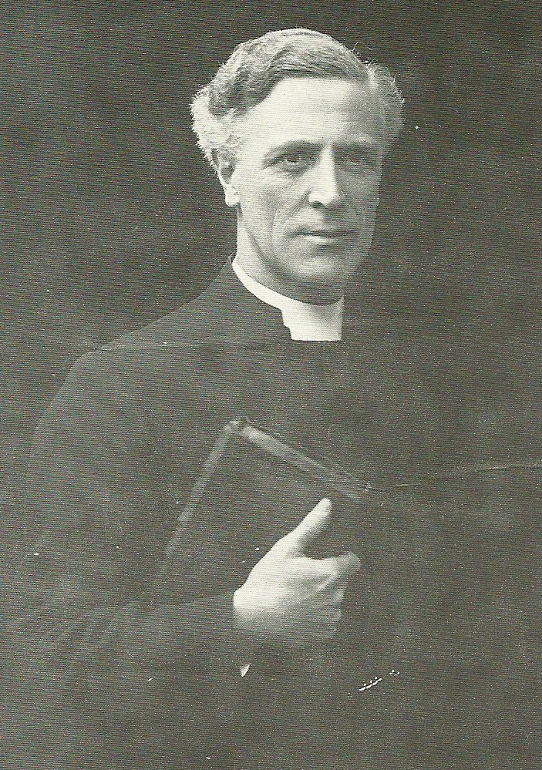
Douglas Brown was the son of Archibald Brown, the pastor of the East London Tabernacle and who was a great influence on his son. Douglas Brown not only listened to his father preach, but “as a little schoolboy of ten, on Friday nights I used to unlace my boots and take them off and creep along from the room where I was supposed to be doing my homework to the door of my father’s study. ... Every Friday night father was in his study preparing for Sunday, and he used to pray. What I heard through that keyhole was more wonderful than what I heard from the platform on Sunday morning. I heard a big strong man telling Jesus that he was nothing, that Jesus was everything. I heard the agony of Calvary. I listened to somebody who understood the fellowship of the suffering of his Lord, until on Friday nights he was as it were, hanging on the cross with Jesus: “I am crucified with Christ: nevertheless I live; yet not I, but Christ lives in me.” I could not understand it all as a little boy, but it gripped me. I feel the aftermath of it today.”
Monday 7 March 1921 - Lowestoft, England (Douglas Brown)
Douglas Brown, a Baptist minister in South London, saw conversions in his church every Sunday until he began he began itinerant evangelism in 1921. Within eighteen months he then addressed over 1700 meetings, and saw revival in his evangelistic ministry. The Lord had convicted him about leaving his pastorate for mission work. Although reluctant, he finally surrendered. 'It was in February 1921, after four months of struggle that there came the crisis. Oh, how patient God is! On the Saturday night I wrote out my resignation to my church, and it was marked with my own tears. ... Then something happened. I found myself in the loving embrace of Christ forever and ever; and all power and joy and blessedness rolled in like a deluge. How did it come? I cannot tell you. Perhaps I may when I get to heaven. All explanations are there, but the experience is here. That was two o'clock in the morning. God had waited four months for a man like me; and I said, "Lord Jesus, I know what you want; You want me to go into mission work. I love Thee more than I dislike that." I did not hear any rustling of angels' wings. I did not see any sudden light' (Griffin 1992:17-18).
Hugh Ferguson, the Baptist minister at London Road Baptist Church in Lowestoft on the East Anglia coast had invited Douglas Brown to preach at a mission there from Monday 7th to Friday 11th March. The missioner arrived by train, ill. However, he spoke Monday night and at meetings on Tuesday morning, afternoon and night. The power of the Holy Spirit moved among the people from the beginning. On Wednesday night 'inquirers' packed the adjacent schoolroom for counselling and prayer. Sixty to seventy young people were converted that night, along with older people. Each night more packed the 'inquiry room' after the service. So the mission was extended indefinitely. Douglas Brown returned to his church for the weekend and continued with the mission the next Monday. By the end of March the meetings were moved from the 700 seating Baptist Church and other nearby churches to the 1100 seating capacity of St John's Anglican Church.
March saw the beginning of revival in the area. Although Douglas Brown was the main speaker in many places, ministers of most denominations found they too were evangelising. Revival meetings multiplied in the fishing centre of Yarmouth as well in Ipswich, Norwich, Cambridge and elsewhere. Scottish fishermen working out of Yarmouth in the winter were strongly impacted, and took revival fire to Scottish fishing towns and villages in the summer. Jock Troup, a Scottish evangelist, has visited East Anglia during the revival and ministered powerfully in Scotland.

The herring fishing was a migratory occupation, and in the latter half of September each year hundreds of small fishing craft - usually nine or ten men to a boat - would sail from all over Scotland to their autumn base in East Anglia in pursuit of the 'sliver darlings'. In addition, around 3,000 women would make their way on specially chartered trains to help with the gutting, pickling and barrel packing. It was estimated that at least 700 Scottish drifters (around 7,000 men plus 3,000 fisher lasses were based in East Anglia at the peak of the season, as well as many hundreds of local vessels. Indeed whole families would travel south for these few months, children being sent to special schools in the area.
The two largest ports in the district were Lowestoft and Great Yarmouth; indeed, the latter town was the largest herring fishing port in the world at the time, its harbour extending for two miles along the sea front. In nearby Lowestoft, the most easterly town in Britain, with a population of 44,000, a revival had begun in London Road Baptist Church, led by Scotsman Hugh Ferguson, in the spring of 1921. Previous to this, a flourishing weekly Bible class and an active prayer meeting had been carried on in the church for two years, with considerable interest being shown by young people. Prayer had reached a crescendo in the early weeks of 1921, but it was during a series of meetings conducted by the Rev. Douglas Brown, a former seaman from Balham, South London, that the 'cloudburst' broke and ‘rain from heaven’ poured down. Hearing of the blessing taking place, people flocked to the meetings from surrounding areas and over subsequent weeks there occurred scores of conversions. Lowestoft was set on fire for God. Returning to the town on Whitsun week (the seventh week after Easter), Brown conducted services that were considered 'the most remarkable of the whole series'. He also preached in churches, barns and the open air to large crowds in the districts around Lowestoft, while he witnessed a similar intense spiritual interest in the larger towns of Norwich, Cambridge and, especially, Ipswich.
However, in nearby Yarmouth it was not until October that revival was unleashed in full power. A year previously one could hardly have predicted that awakening would occur in Lowestoft or Yarmouth at any point in 1921. While the United Free Church of Scotland applauded the fact that the fishermen in these towns ‘maintain better than any other class of working people their interest in religious observances’, they nonetheless found attendance at Sunday services in 1920, ‘disappointing’. Two facts were blamed for this; first, the building in Yarmouth used for Presbyterian services was in a state of disrepair. Secondly, the churches have not always sent the right type of man to minister to fisher-folk. Getting plenty elbow-room at sea, the fisherman has a partiality for a whiff of freedom ashore, and he is disposed to allow himself more unconventionality in his mode of worship than some ministers and churches seem able to understand’.
Among the Scottish migrants to East Anglia in 1921 was a young cooper (barrel-maker) from Wick in the north of Scotland by name of Jock Troup. He was born in Dallachy on the Moray Firth coast, Troup was brought up in Wick by Christian parents. It was while serving in Dublin in 1918 in the final months of the Great War that the young man became a follower of Christ. Receiving a further deep and 'definite experience with the blessed Holy Spirit' in Aberdeen just prior to his departure for Yarmouth, Troup arrived in that East Anglian town very much on fire for the Lord.
1921 was an 'annus terriblis' for the Scottish herring industry. In the spring of that year the Government revoked subsidies that had been granted to curers in the two years following the end of the War. The industry was also fatefully dependent on Continental markets, especially those of Russia and Germany; but now a depressed, inflation-ridden German economy, along with the severance of Russian-European ties for a number of years after the Bolshevik Revolution in 1917, resulted in desperate conditions for the British herring trade, which never managed to fully recover. Besides this, only meagre catches of fish were made during the summer, while in East Anglia an Indian summer and particularly calm weather initially stopped the fish from surfacing. To add insult to injury, in November continual heavy gales caused boats to be tied up in harbour for days on end.
In any case, the religious tradition of the Scots fisher-folk meant that they never ventured to sea on a Sunday, so once catches were cured and packed on Saturday, the workers were free till Monday morning, and would spend Saturday evening strolling through town, chatting and relaxing. Taking advantage of the situation, Troup began holding open-air meetings where, sometimes for hours on end, his booming emotion-laden voice would ring through Yarmouth’s market square and beyond. On the third Saturday in October, as Jock preached from Isaiah 63:1 and as a young fisherman from Cairnbulg boldly sang out his testimony in song, the Spirit of God moved in power. Scores of men and women were convicted in spirit, and many fell to the ground under His might. One such ‘victim’ later claimed 'The ground around me was like a battlefield with souls crying to God for mercy’. Jock picked his way through the scene, attending to those who were affected with prayer and counsel as necessary. Another mighty move of the Spirit had begun, and over the next few weeks, dozens of men, women and children were brought to their knees in repentance of sins – thereafter being led to wondrous new life in Christ.
Conversion accounts were frequently dramatic, and always noteworthy. One young man, Alex Thain from Portgordon, was strolling through the Market Place one Saturday evening with five friends, and, being arrested by the singing of hymns in the square, stopped to listen. Soon he realised he was standing on his own; his pals having responded in unison to the gospel message being proclaimed! (It was at the same open-air meeting that Alex's future wife was converted, while Alex himself came to Christ a few years later). Troup held open-air meetings every night and thrice on a Sunday, while services were also conducted in local churches. On average, around 65% of audiences consisted of fishing folk from north of the border.
Deep conviction would also come over workers as they laboured in the curing yards and while resting in their lodging houses and it was not uncommon for the manager of a curing yard to call on Jock at all hours of day to deal with these wounded souls so they could get back to work as soon as possible! One Monday morning Jock was asked to call along the lodging house of three young fisher lassies from Lewis who were under deep agony of soul. All three were led to Christ, and with joy in their new-found salvation, were able to return to their work among the herring.
Many others were convicted and saved out at sea; some after being reminded of the fires of hell as they stoked the boat's coal-fired boilers; others during the long hauling operations (which could last up to ten hours) as they pulled in their heavy nets. Sometimes a man would come under such conviction that he would let go of the net he was drawing in, fall to his knees, and cry out for salvation. Many telegrams were sent home to Scotland relating wonderful stories of conversion. One read 'Saved, 10 miles from Knoll Lightship, last to ring in on this ship.' There was another fisherman, the father of Jackie Ritchie, who was converted in the engine room of a herring-drifter eight miles from the Haisboro’ lightship, off the coast of Norfolk.
Douglas Brown arrived in Lowestoft at the beginning of November and for a short time he and Troup worked together in evangelistic outreach. Meetings often lasted for hours, and one notable scenario occurred when the two evangelists stood together in the pulpit of Deneside Methodist Church, arms entwined, basking together in the presence of God. Shortly after this, Troup experienced a vision of a man in Fraserburgh asking God to send Troup to his town. Because of the demands on his time as an evangelist, Troup had recently been released from his job as cooper, and, despite earnest pleas from friends to remain in Yarmouth where revival was in full swing, Jock resolved to be obedient to the 'call', and he set off for Scotland the next day.
Meanwhile, in Yarmouth the Spirit of God continued to move in unabated power. Ministers and students came from various quarters to assist Brown in what was termed 'Yarmouth's wonderful ten days.' Hundreds of requests for prayer poured in to the Morning Prayer meetings. 700 people braved blizzard conditions to attend the afternoon services and over 1,500 packed into each of St. George's and Deneside Churches, many being forced to stand in the aisles or sit on the windowsills. The 5th of November was especially memorable to Brown; 'We started at six o' clock and went on until eleven’, he recalled. ‘No one was asked to pray but it was all prayer. The power of God was so terrific that we ministers on the platform could do nothing as those dear Scottish fellows prayed. I shall never forget the scene, nor recover from the sense of God's presence at that meeting. The fisher-lads prayed for their brothers, the fisher-girls prayed for the other girls lodging in the same house. Singing, sobs and prayer prevailed in all parts of the building. After a while’ we thought it would be good to have testimonies. When Jesus is really in a place and there is a sense of sin and a vision of Calvary, the atmosphere is so gentle, so pure, that a few soft words only were needed to ask for testimonies. I will shut my eyes and picture the scene. Up gets a man from Stornoway and says in his Scottish accent, “Let's have number 46.” In a moment the Scots girls had taken up the old metre and the place was ringing with "He drew me out of the horrible pit." It was as those lasses sang and the strong hefty fishermen joined in, many of them sank down on their knees. Then a lad got up and said, “I gave myself to God in the fish market last week, and it has been the best week I ever had!”....I tell you frankly, if a man could pass through a meeting like that without breaking his heart with joy, he must be made of granite’.
Despite the horrendous rain and hurricane-force winds, open-air meetings continued each evening, and it was in such conditions on November 6th that 22 men went on their knees on the wet ground to commit themselves to Christ; this after having attended a four-hour prayer meeting! Other conversion stories are equally dramatic. One man living in the north of Caithness came under deep conviction after hearing of events in East Anglia, and after reading one of Brown's sermons was advised by his doctor to pay a visit to Norfolk. He did, was soundly converted, and quickly returned home to make up for time lost at work due to his previous distress, and to witness to his two sons, both of whom turned to the Lord soon thereafter.
The skipper of one trawler had two sons who were also crewmen on his small vessel. Following a family feud, the younger brother attempted suicide by jumping overboard into the harbour, but was saved in ‘the nick of time’ when a rope was flung to him. The following evening on passing St. George’s Church, the young man was attracted by the singing from within. On entering he saw that his father and brother were among the congregation, and at the close of the service all three went forward to give their lives to the Lord. Overjoyed at this, the skipper proceeded to request prayer for the rest of his crew, and by the end of the week all seven other crew-members were wonderfully converted!
Towards the close of November, the Scottish 'armada' prepared for the voyage homeward. For some this was to the fishing ports of Fife or towns and villages to the east and south of Edinburgh such as Cockenzie and Eyemouth. For others it was a much longer journey to towns and villages along the Moray coast or further north still to the likes of Wick, Lewis or even Shetland. The onshore workers left by train soon after, having painstakingly cleared up the curing yards. But whatever the mode of transport, new songs accompanied the blessed fisher-folk, who joyfully sang out the delights of their new-found salvation as they journeyed. One fisherman summed up 1921 as 'of all years, the worst for our pockets, but the best for our souls’.

At the same time, the spirit of God moved strongly in Ireland, especially in Ulster in 1921 through the work of W. P. (William Patterson) Nicholson a fiery Irish evangelist. This was at the time when Northern Ireland received parliamentary autonomy accompanied by and tension and bloodshed. Edwin Orr was converted then, although not through W. P. Nicholson. Orr wrote: 'Nicholson's missions were the evangelistic focus of the movement: 12,409 people were counselled in the inquiry rooms; many churches gained additions, some a hundred, some double; ... prayer meetings, Bible classes and missionary meetings all increased in strength. ... Ministerial candidates doubled' (Griffin 1992:87).
In Great Britain, the Welsh Revival of 1904-5 impacted the nation. Though not as widespread or as intense, the revivals of 1921-2 touched thousands following the devastation of World War I. Revival flamed again in 1948-9 after World War II, especially in the Scottish Hebrides.
After twenty-six years of apparently successful ministry in a large London Baptist church, Douglas Brown became acutely aware that something was missing from his life: "Christ laid His hand on a proud minister, and told him that he had not gone far enough, that there were reservations in his surrender . . . He nearly broke my heart while I was preaching." Throughout November and December of 1920, an intense struggle went on; it carried on through to January of the following year. Then in February 1921 Douglas Brown was wrestling in prayer when he felt able to yield his life fully to God. "Then something happened. I found myself in the loving embrace of Christ forever and ever; and all power and all joy and all blessedness rolled in like a deluge . . . God had waited four months for a man like me; and I said: ‘Lord Jesus, I know what You want; You want me to go into mission work. I love Thee more than I dislike that.'" In the same month, while Douglas Brown was conducting a mission in Lowestoft in Suffolk, God began a revival that spread all over East Anglia and up into the fishing ports of Scotland.
The men God uses in revival know that sin will quench the Holy Spirit, and their passion for God is equalled only by their fear of offending Him. These are not men who take God lightly. Men used in revival have a great opinion of God and are touch-sensitive to sin, long before the revival comes.
Not only are the leaders in revival men with a deep experience of God and a passion for holiness, but, as we should expect, they are men who are obedient to the Word of God. All who have been used by God in spiritual revival were diligent in the study of Scripture and the application of the Scripture to their own lives.
Douglas Brown described revival as "the humbling of self before the . . . majesty of that consciously present Jesus." God brings revival not for the enjoyment of His people, but for the glory of His Name; and He will not share that glory with men. The moment men boast of their achievements the glory will depart.

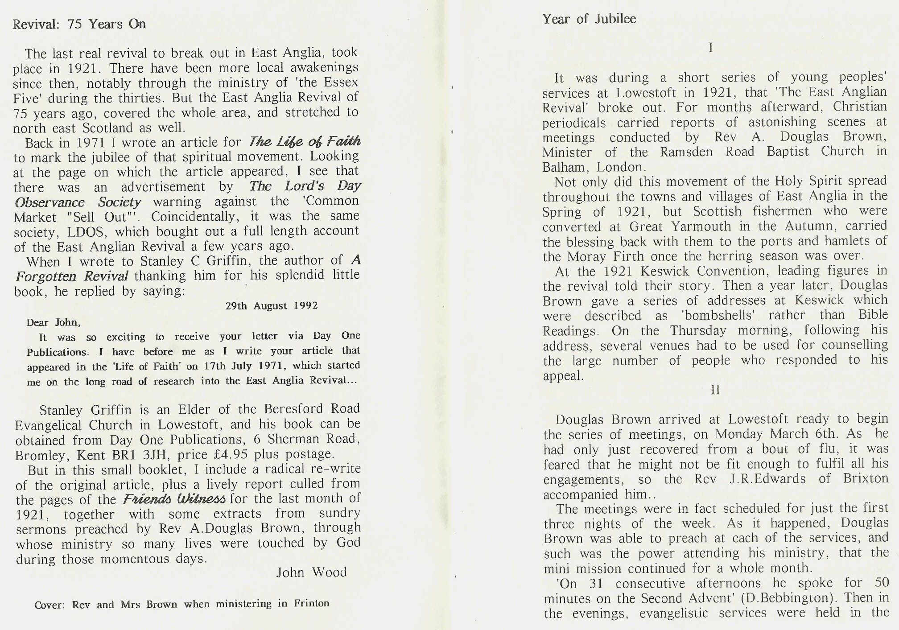

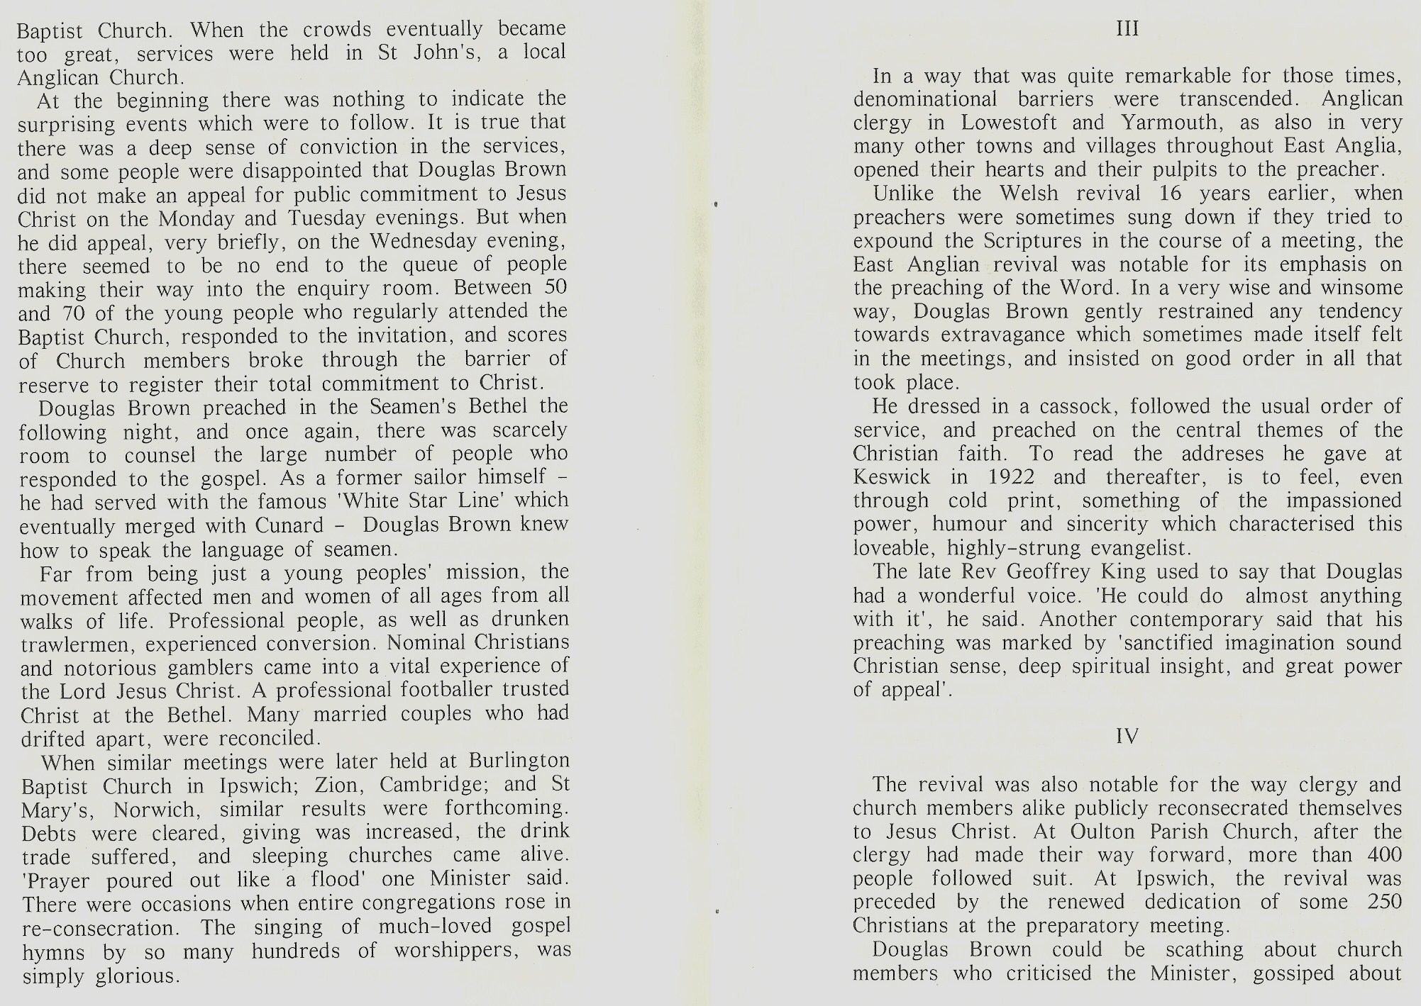

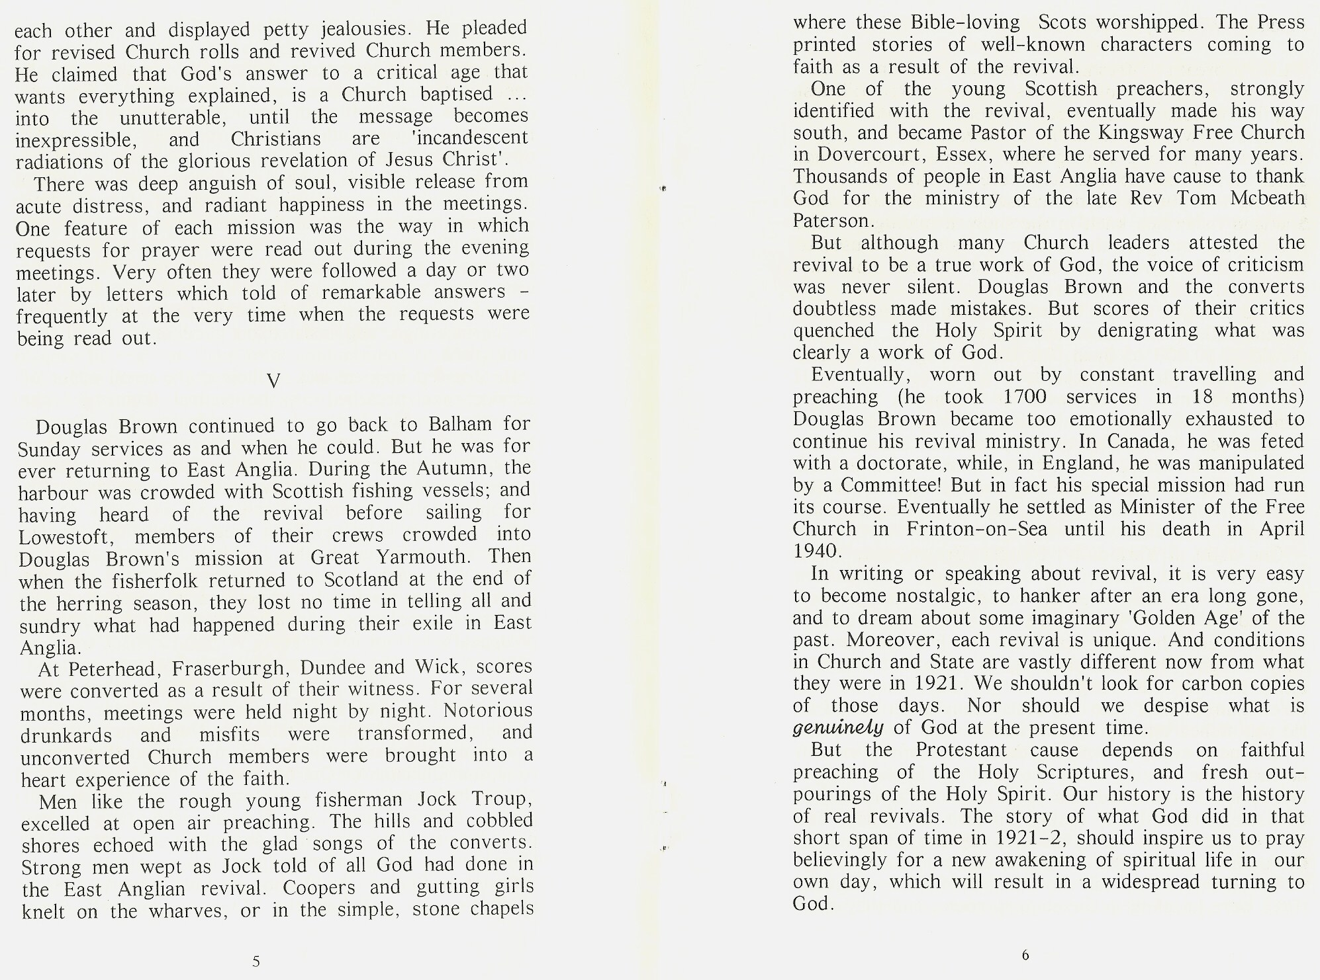

‘Missionary Record’ 1921 p48 suggests 20,000 men from Scotland
In the districts surrounding this latter town, Lionel Fletcher, too, observed a notable move of the Spirit (Lionel Fletcher ‘Mighty Moments’, London 1932 pp89-94). Meanwhile, news of the revival brought invitations from far and wide for Brown to preach. Marked awakening resulted in Ramsgate, Southampton and other parts of south England between September and November, 1921, while in Sunderland over 600 made first-time commitments.
In the districts surrounding this latter town, Lionel Fletcher, too, observed a notable move of the Spirit (Lionel Fletcher ‘Mighty Moments’, London 1932 pp89-94). Meanwhile, news of the revival brought invitations from far and wide for Brown to preach. Marked awakening resulted in Ramsgate, Southampton and other parts of south England between September and November, 1921, while in Sunderland over 600 made first-time commitments.
In the districts surrounding this latter town, Lionel Fletcher, too, observed a notable move of the Spirit (Lionel Fletcher ‘Mighty Moments’, London 1932 pp89-94). Meanwhile, news of the revival brought invitations from far and wide for Brown to preach. Marked awakening resulted in Ramsgate, Southampton and other parts of south England between September and November, 1921, while in Sunderland over 600 made first-time commitments.
In the districts surrounding this latter town, Lionel Fletcher, too, observed a notable move of the Spirit (Lionel Fletcher ‘Mighty Moments’, London 1932 pp89-94). Meanwhile, news of the revival brought invitations from far and wide for Brown to preach. Marked awakening resulted in Ramsgate, Southampton and other parts of south England between September and November, 1921, while in Sunderland over 600 made first-time commitments.
Ibid
Ibid
Ritchie ‘Floods Upon the Dry Ground’ p30
Ritchie ‘Floods Upon the Dry Ground’ p30
Ritchie ‘Floods Upon the Dry Ground’ p30
Ritchie ‘Floods Upon the Dry Ground’ p30
A ‘Scotsman’ journalist stated, apparently on good authority that it was ‘at Lowestoft and Yarmouth that the appeals of the evangelists of the north-east who were temporarily quartered in those places make comparatively slight impression upon their English fellow-craftsmen, whose religious sense does not appear to be nearly so well developed’ (‘The Scotsman’ 21/12/21 p9)
Ritchie ‘Floods Upon the Dry Ground’ p2
William Leed of the Salvation Army speaks of a third ‘independent spiritual spearhead’ operating in East Anglia in 1921 in addition to the ministries of Troup and Brown. Staff Captains Albert Osborn and Gordon Simpson at Clapton were ‘undoubtedly divinely directed to arrange a Charabanc (open-decked bus) Crusade, comprising Training Officers and Sergeants (of which Leed was himself a member) in widely scattered East Anglia, which brought to Christ a multitude of souls – 106 in Norwich alone. Towns and villages were invaded by Crusadets, morning, noon and nights, with outstanding response’ (William Leed ‘The Strategy of God’ in Ritchie ‘Floods Upon the Dry Ground’ p98)
Griffin ‘A Forgotten Revival’ pp64-65
‘Glasgow Herald’ 20/12/21

